Unity Team
Matteo Dell’Oro, Alfio Giuliano Faro, Gabriel Logronio

CHARACTERS DOCUMENT

Purpose | Document giving a description of the puzzles of the game
Creation date | 13-12-2017
Current owner | Gabriel Logronio
Last modification | 13-12-2017

Revision History
Who | When | What
Logronio | 13-12-2017 | Created this document

Minefield
During this puzzle Clara separates from the rest of the team as in a minefield there is no room to engage in a fight.
The land is littered with mines not visible to people and patrolled by a group of cybermen guards that can see the mines thanks to their scanners. The player must analyse and memorize the guards path while hiding, as those are free from mines, in order to follow them and get to the generators that feed the surrounding area to turn them off and debilitating both cybermen and the mines.

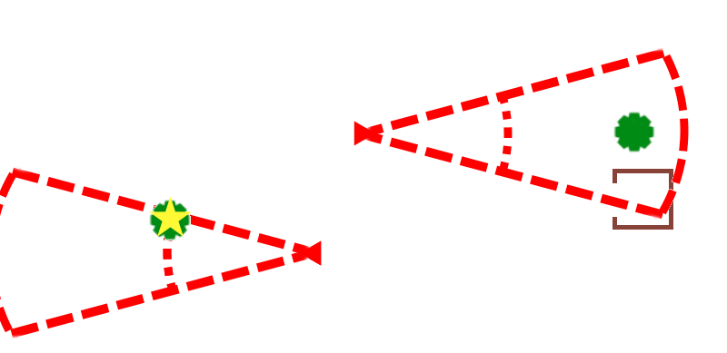 | Starting point, Clara is hiding in a bush and need to get to the generator but she still doesn’t know where the mines are are where she can walk.
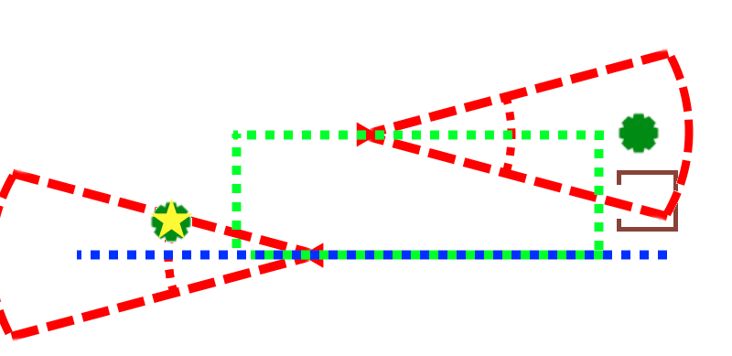 | Observing the cybermen walking, she memorizes their path so she can know where she can walk and where she can not.
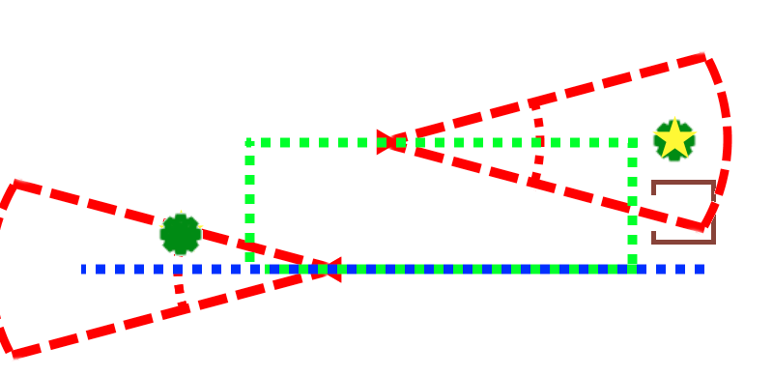 | Using timing and without exiting the safe paths, she manages to reach the second bush.
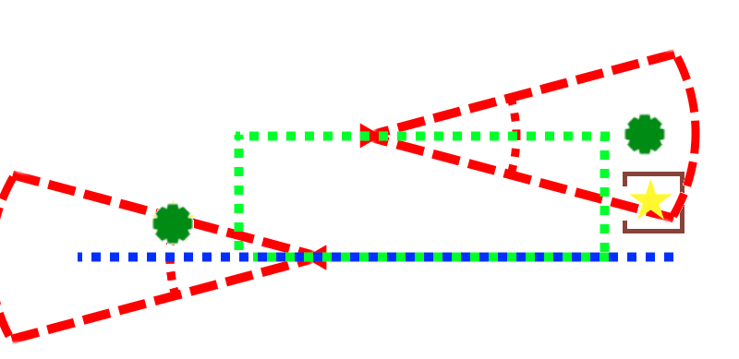 | She then proceeds to deactivate the generator.

Weeping angel
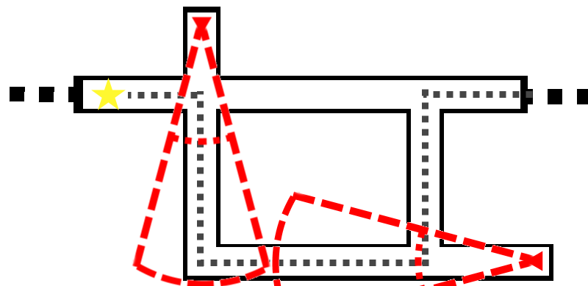 | Starting point: neither of the angels have spotted Clara
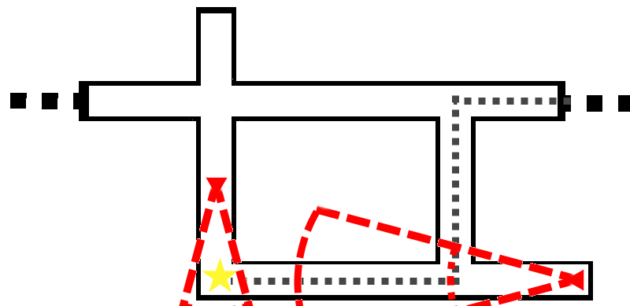 | Clara gets noticed by a weeping angel that starts following her
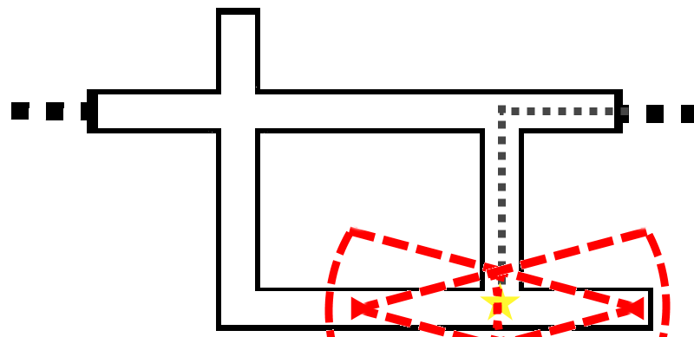 | Clara, still followed by the first angel, walks towards the second angel that can’t move as Clara is facing it.
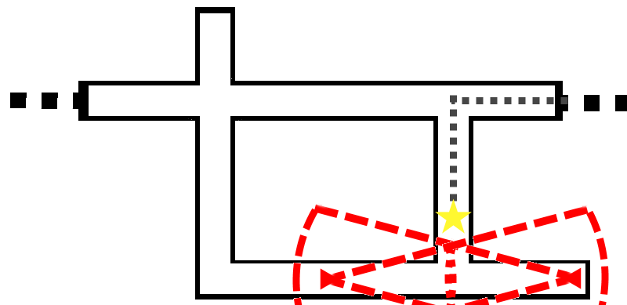 | As Clara turns the angle, both angels face each other destroying themself
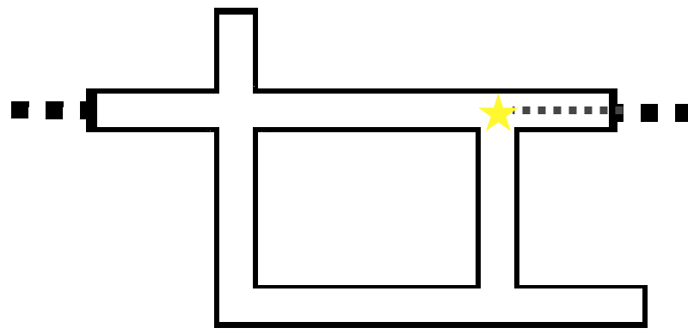 | Now that all the angels that have seen Clara have been destroyed, she can safely exit the area.

Jenny’s hacking skill
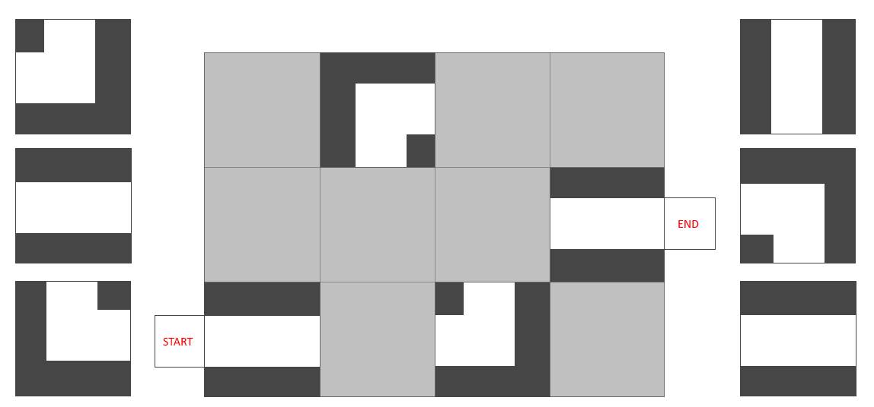
In this puzzle Clara is in a labyrinth with a few weeping angels, as they are too dangerous she can’t leave the area before clearing it from those that have seen her. The weeping angels will follow her even if she gets out of their sight, just as long as she is not facing them, as they will immediately freeze. The aim of the mini game is to make two weeping angels face each other at short distance without anything between them, destroying them.

Jack’s charisma skill
This skill is a simple quiz about doctor who w

